Road Accident Severity & Hospital Recommendation using Deep Learning Techniques

Now-a-days due to increasing population we can see huge traffic on the roads and because of weather condition or driver negligence world witness loss of numerous life in road accidents. After accident it’s mandatory to identify injury severity and based on severity best hospital must be suggested on time to save life. Currently no paper or development work progress in this field so we have decided to focus our work on accident injury severity detection and best hospital recommendation based on injury severity.

In propose work we have employed Convolution Neural Network (CNN) image classification algorithm to classify type of injury like Head, hand or leg and then detect severity of injury based on its size. If size is smaller injury will be consider as minor and if size bigger injury will be consider as major and must take victim to recommended hospital.

CNN algorithm has gain lots of popularity in almost all fields for classification and object detection. Many peoples employed this algorithm for X-ray pneumonia detection, brain tumor detection and many more.

For recommendation we have listed few hospitals for head, hand and leg and then based on injury classification hospital will be recommended.

In propose work we have experimented with deep learning CNN and many machine learning algorithms like SVM, Random Forest and Decision tree. Among all algorithms CNN is getting 100% accuracy. Each algorithm performance we have tested in terms of accuracy, precision, recall, confusion matrix and FSCORE.

To trained and test each algorithm performance we have gather our own dataset images consists of different accidents such as Hand, Leg and Head. In below screen we are showing dataset details

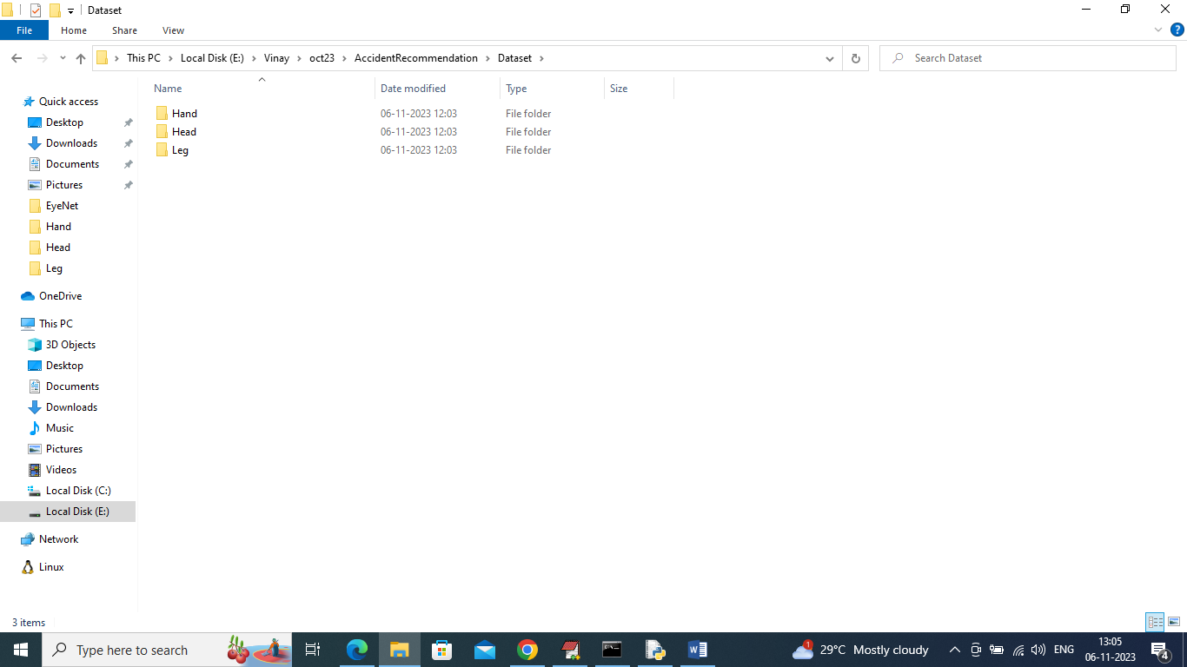

In above dataset folder we have 3 different folders and just go inside any folder to view related images like below screen

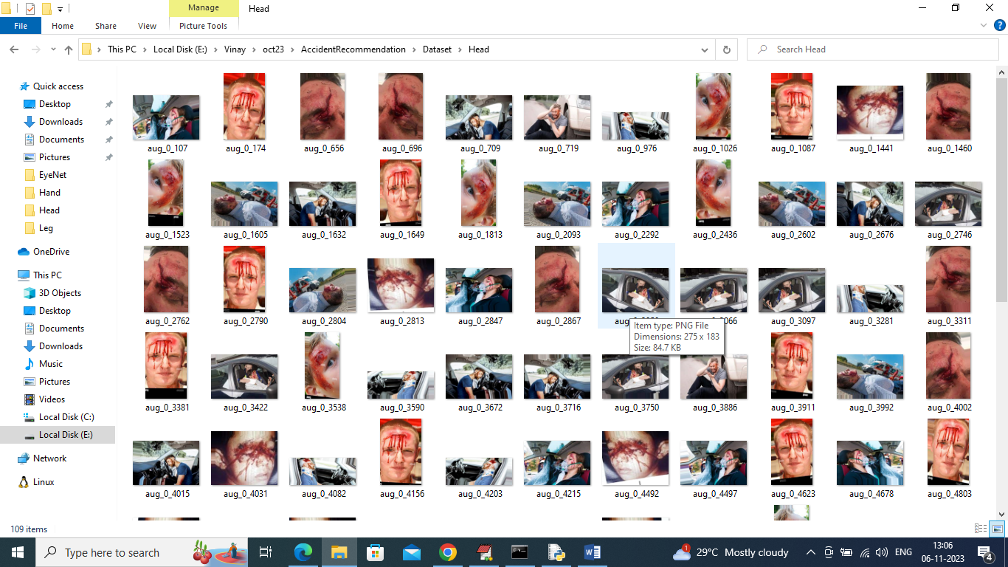

So by using above images will train and test each algorithm.

Note: we have very rare images for accidents so by applying Augmentation techniques we have generated new images from same images by changing rotations.

We have coded this project using JUPYTER notebook and below are the code and output screens with blue color comments

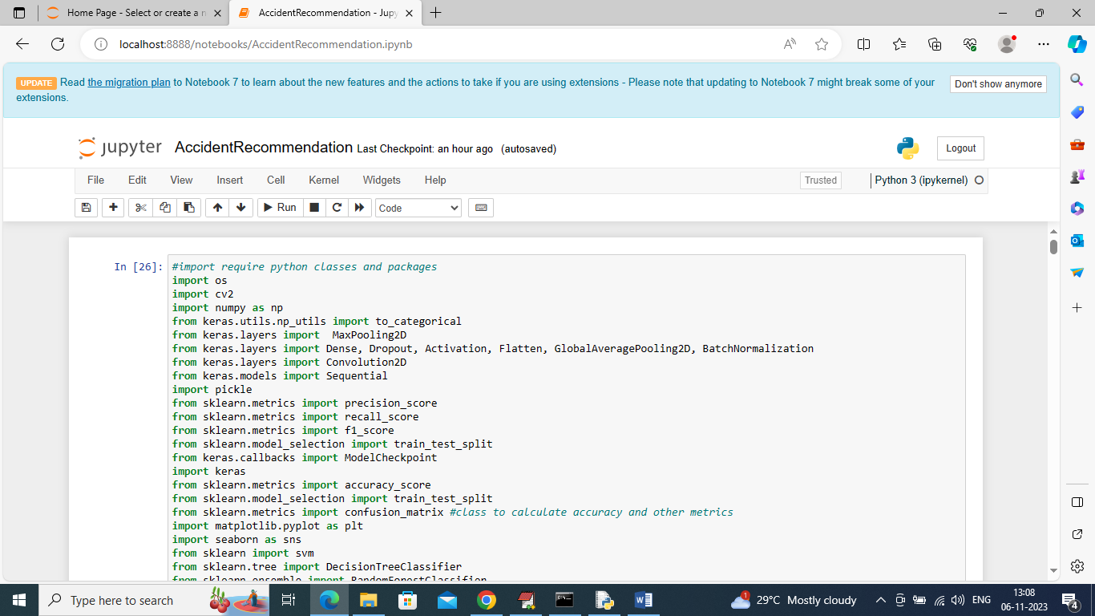

In above screen importing require python classes and packages

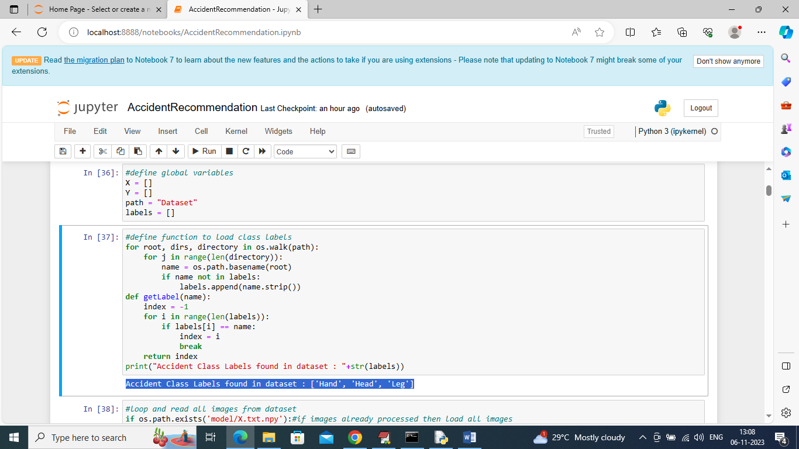

In above screen finding and displaying different class labels found in dataset

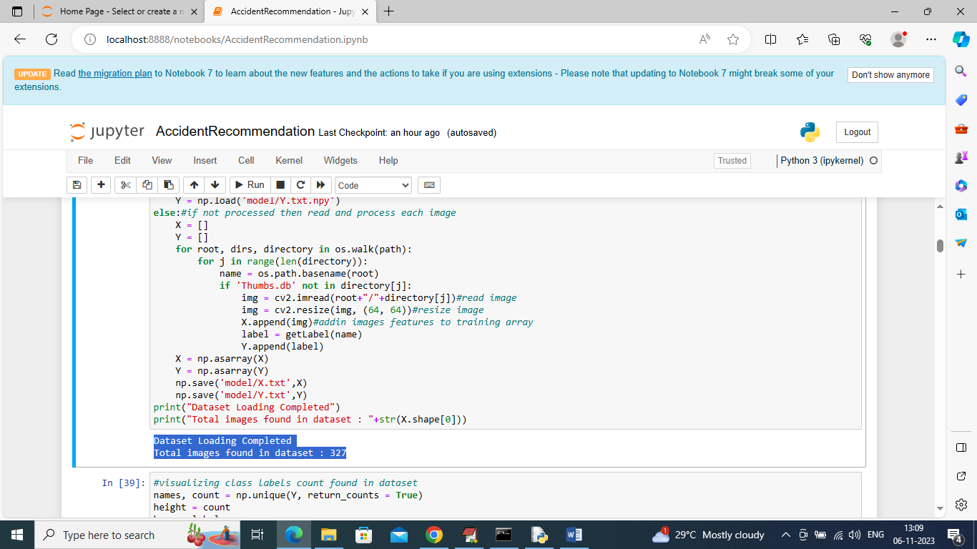

In above screen looping and reading all images from dataset folder and then resizing all images to equal size like 64 X 64 and then in blue color text displaying total number of images loaded

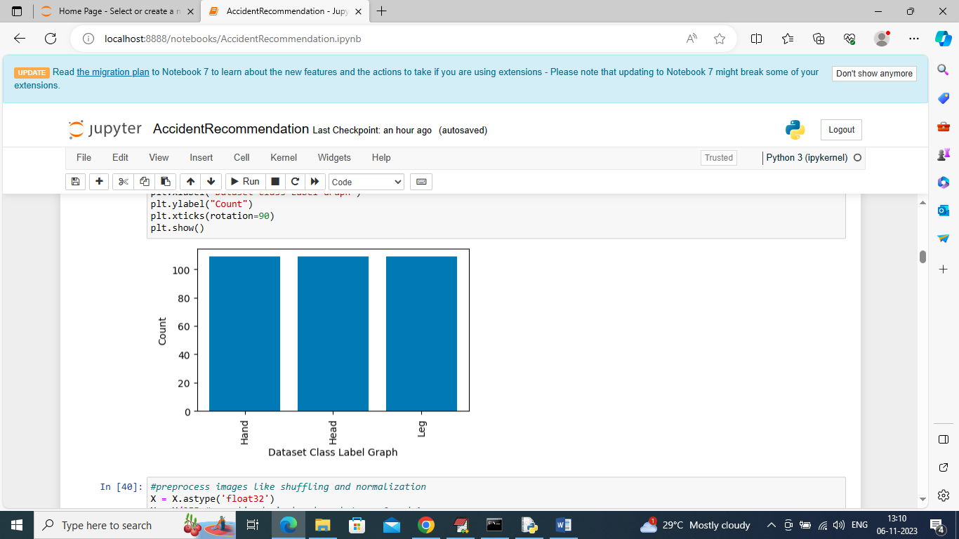

In above graph displaying number of images in graph format where x-axis represents type of images and y-axis represents count

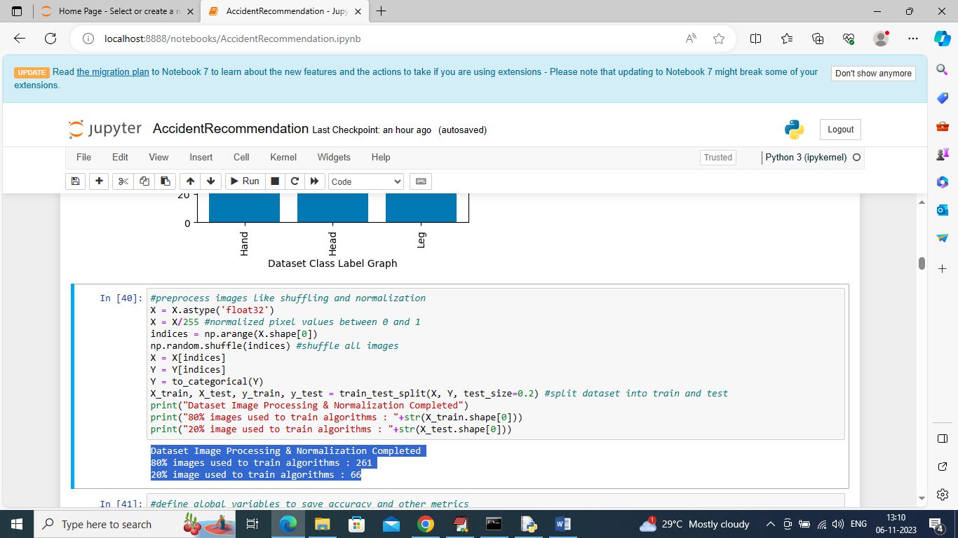

In above screen applying various processing technique like shuffling, normalization and then splitting dataset into train and test where application using 80% dataset images for training and 20% for testing

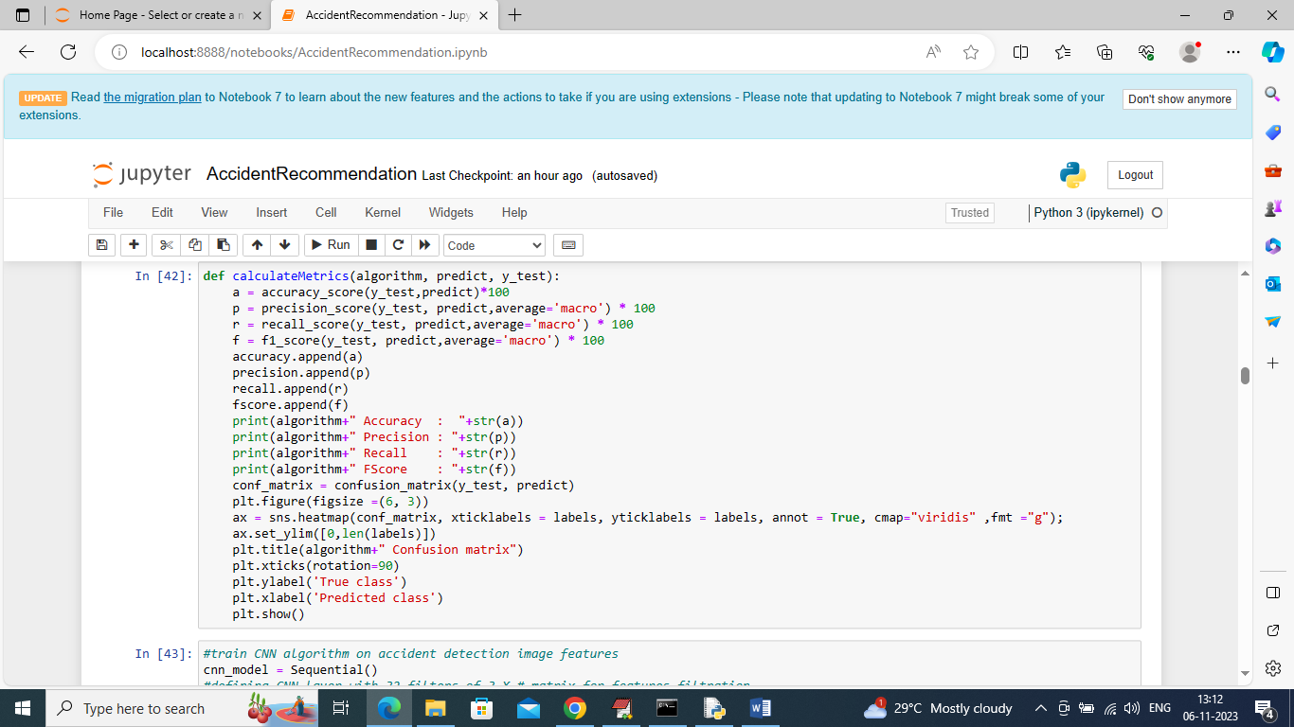

In above screen defining function to calculate accuracy and other metrics

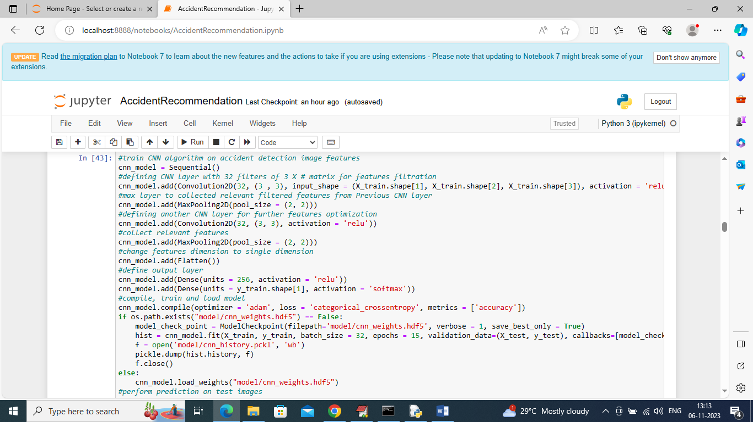

In above screen training CNN algorithm and after execution of this block will get below output

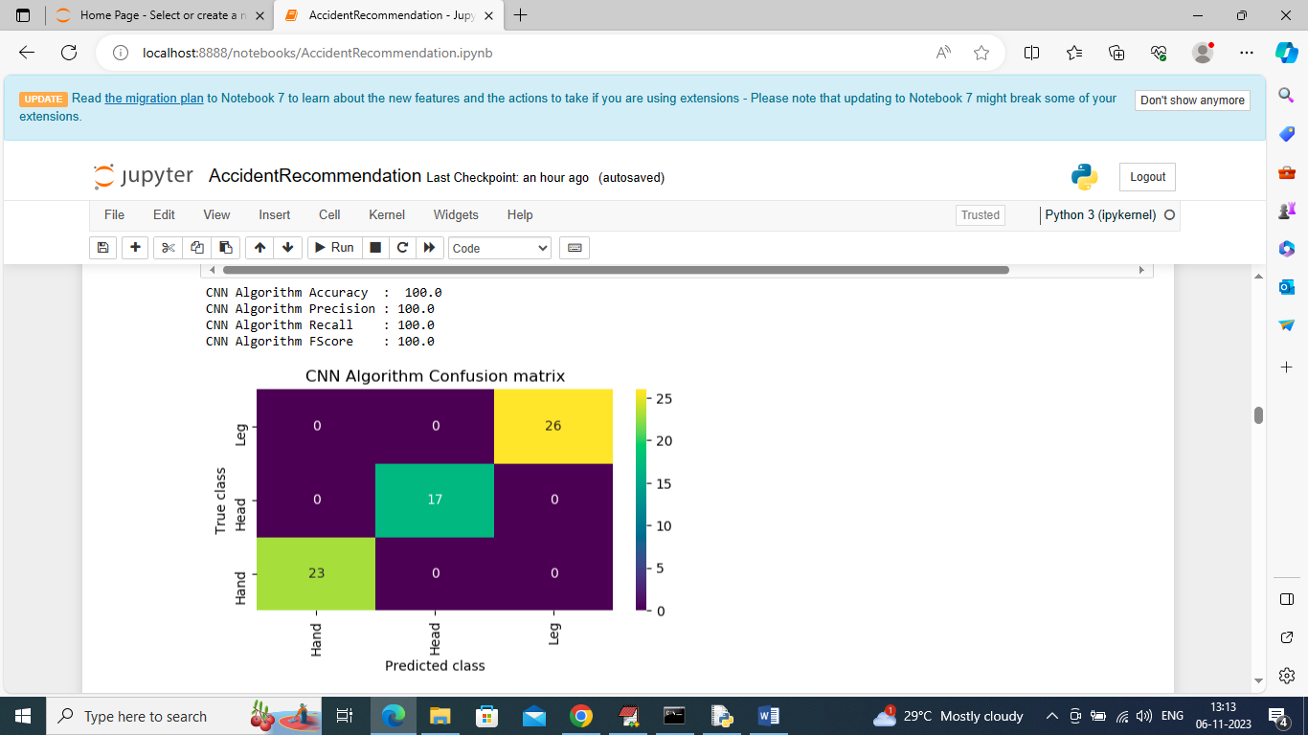

In above screen CNN got 100% accuracy and can see other metrics also and in confusion matrix graph x-axis represents Predicted Labels and y-axis represents true labels and all different color boxes in diagnol represents correct prediction count and remaining blue boxes contains incorrect prediction count which are 0

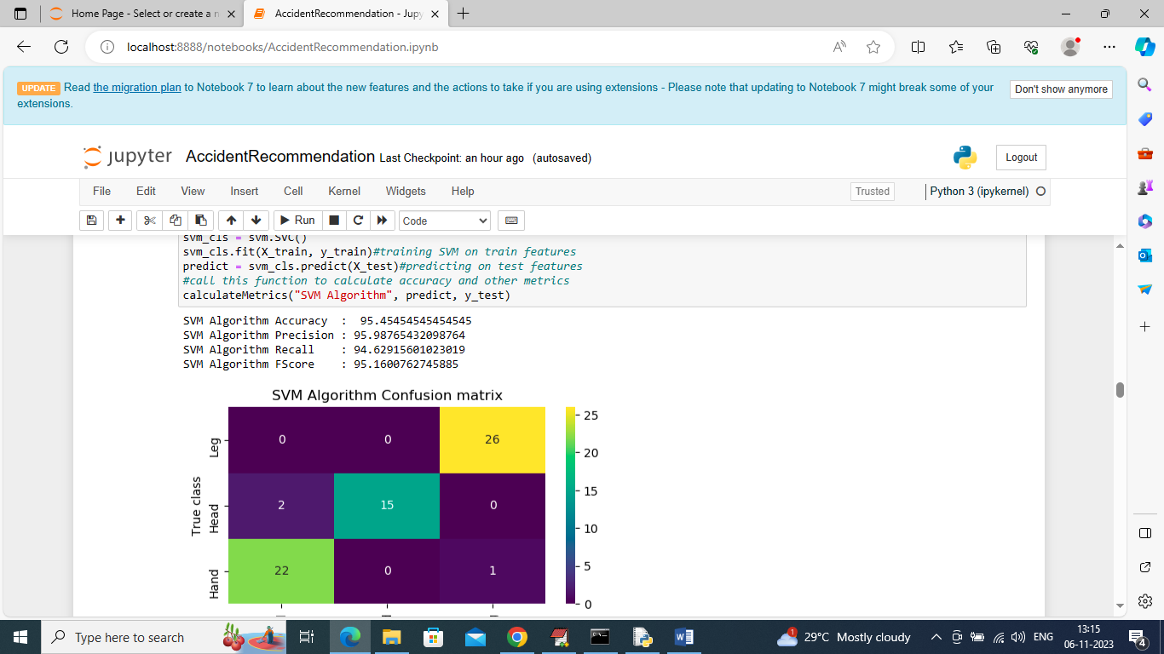

In above screen training SVM on same dataset and it got 95% accuracy and can see other metrics also

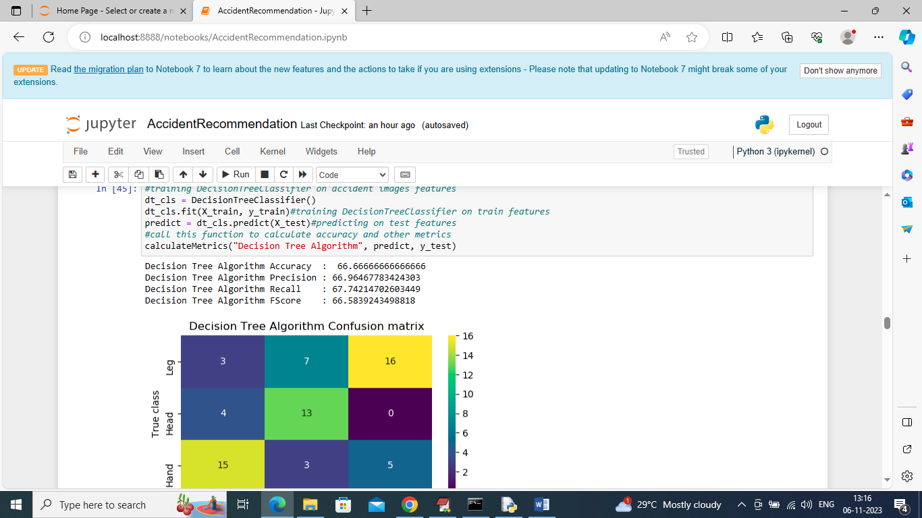

In above screen decision tree got 66% accuracy

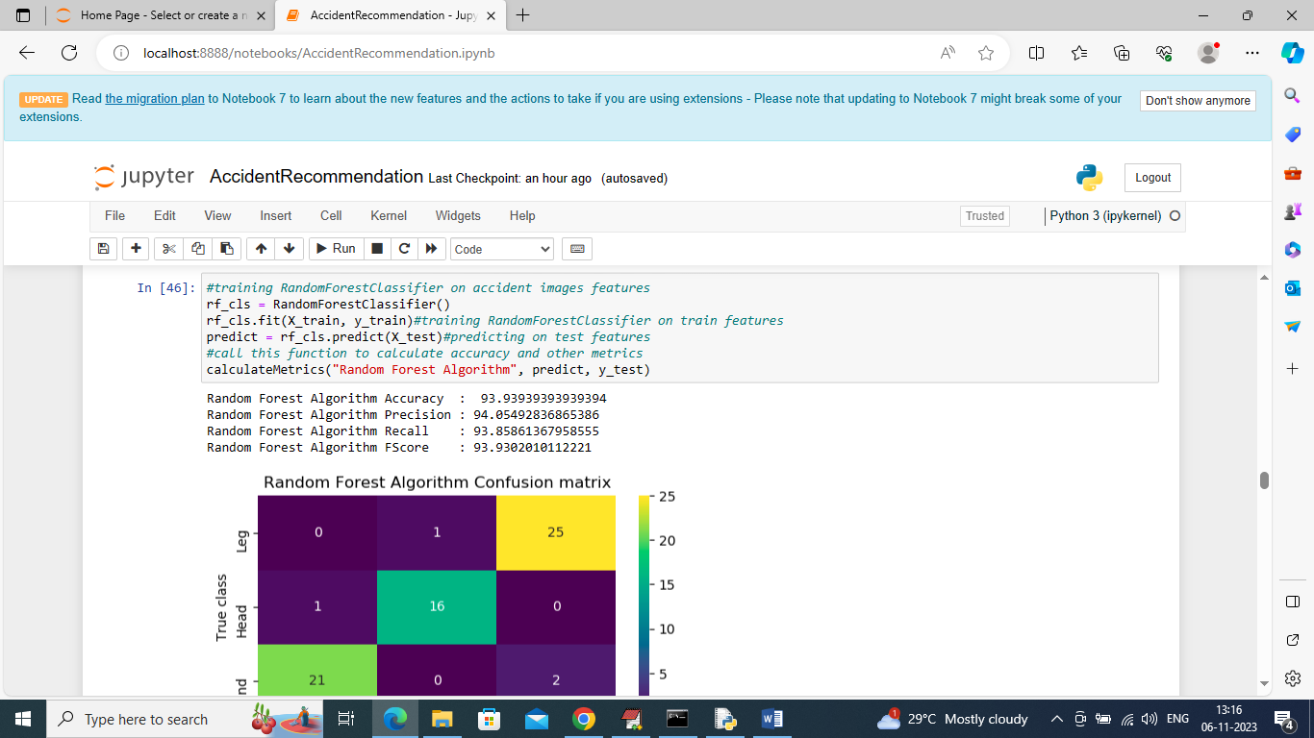

In above screen random forest got 93% accuracy

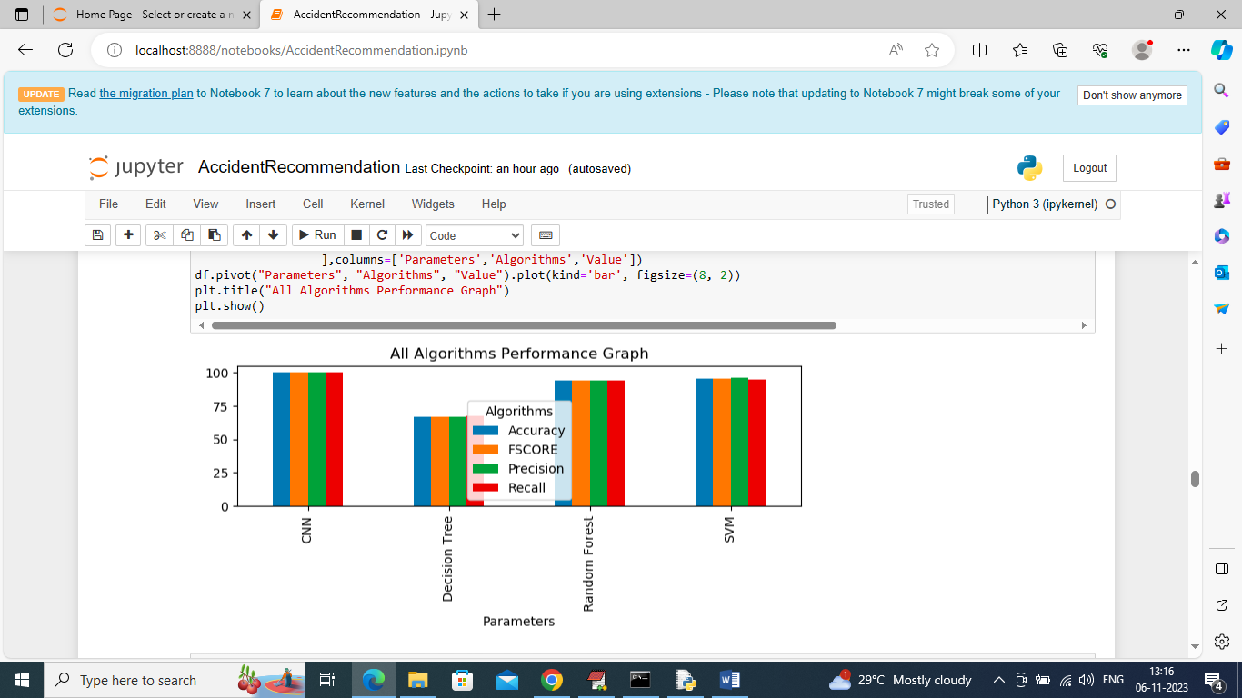

In above screen displaying comparison graph between all algorithms where x-axis represents algorithm names and y-axis represents accuracy and other metrics in different color bars and in all algorithms CNN got high performance

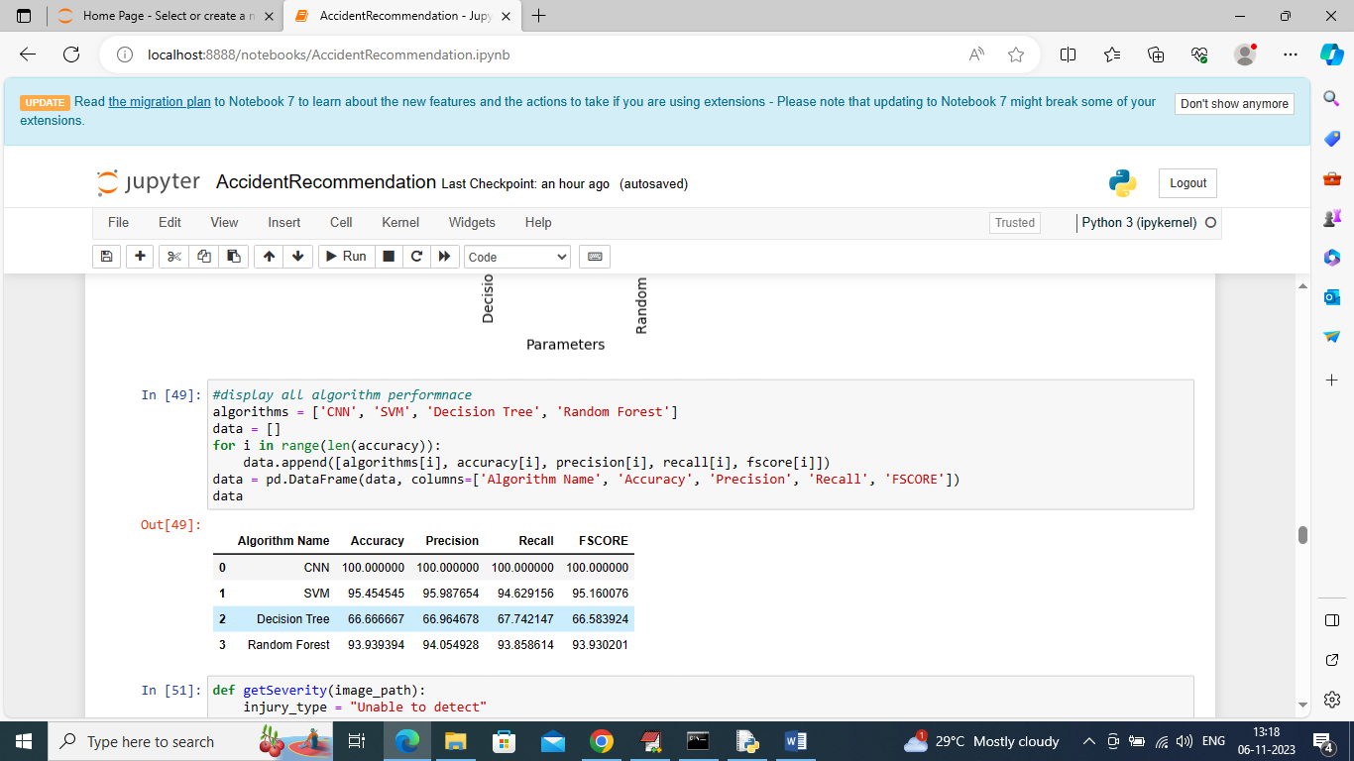

In above screen displaying all algorithm performance in tabular format

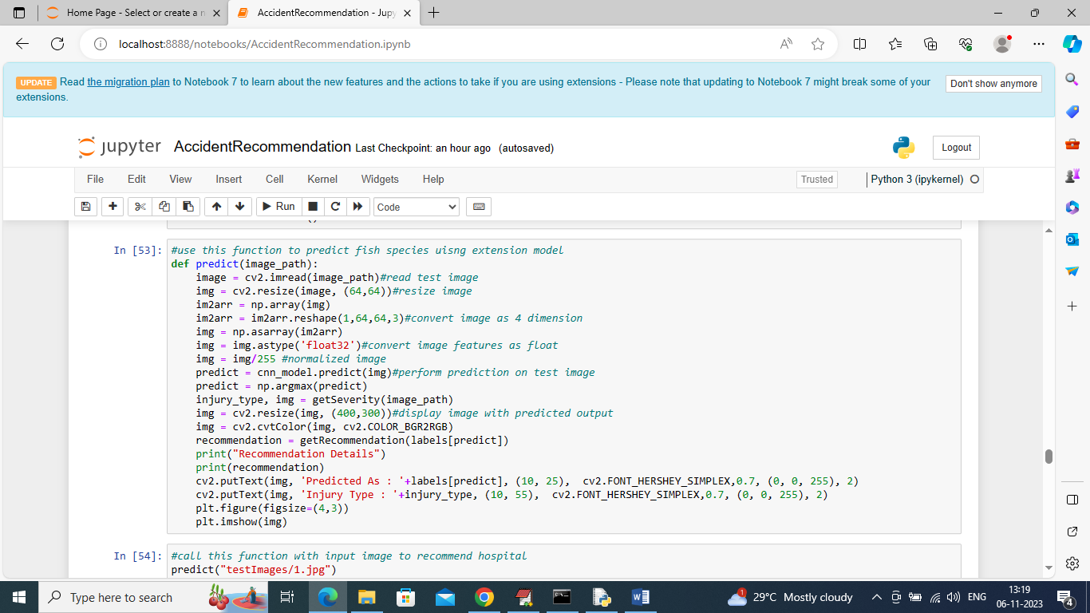

In above screen displaying predict function code which will take test image path and then classify accident, predict severity and recommend hospital

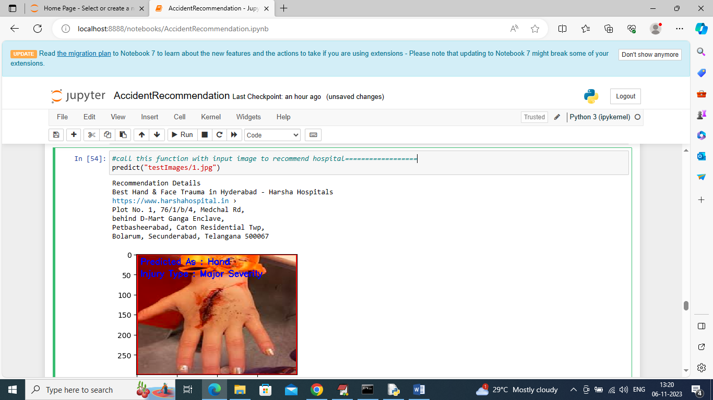

In above screen calling predict function with test image path and then in blue color text we can see accident type is Hand and predicted Injury is MAJOR and above that we can see recommended hospital details

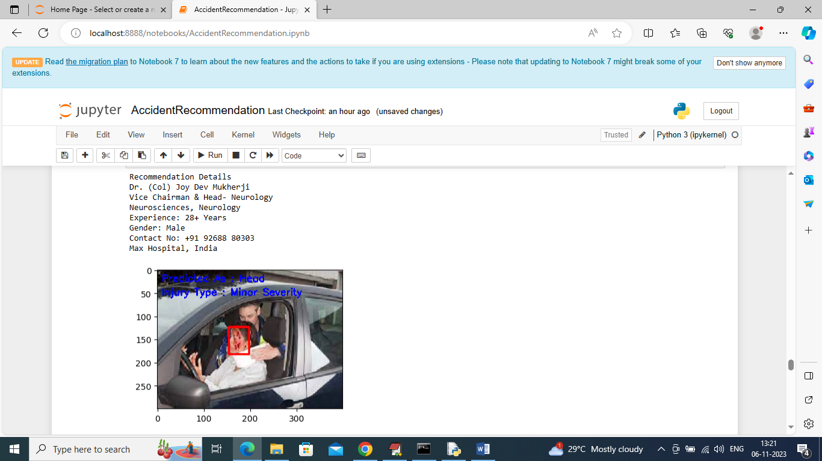

In above screen can see another test image output

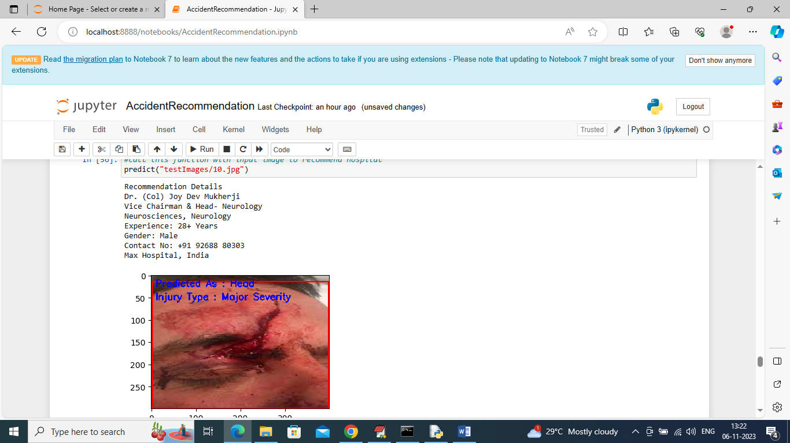

Another output

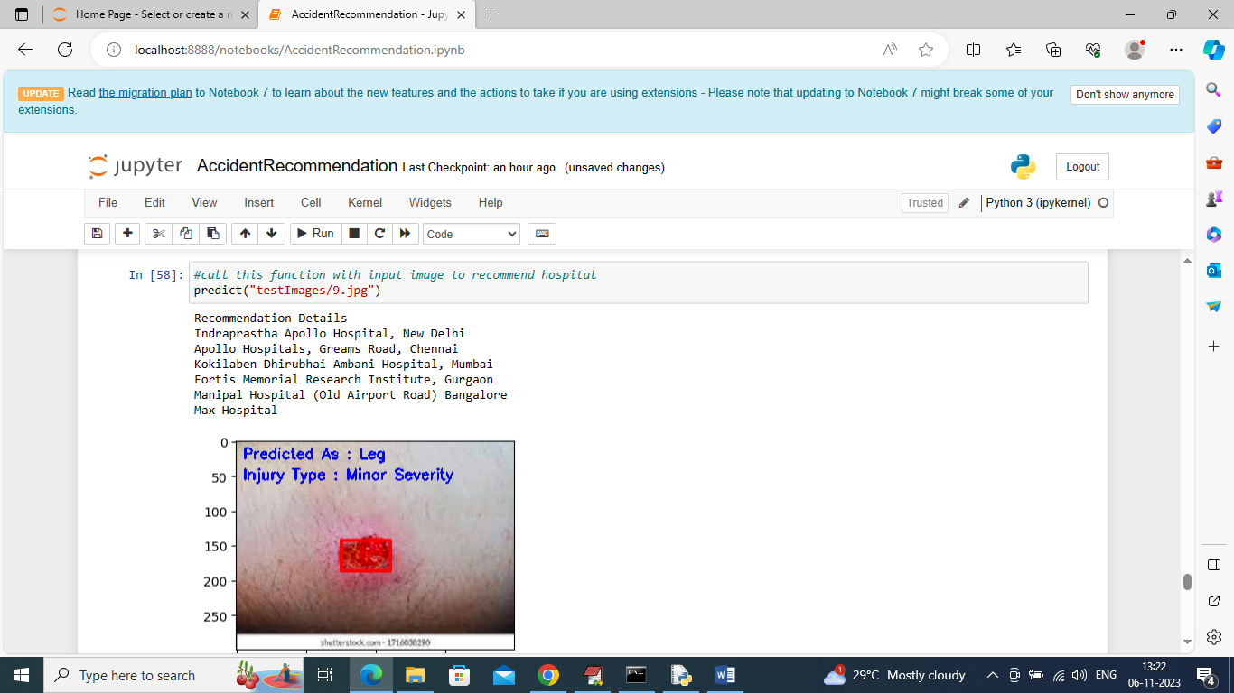

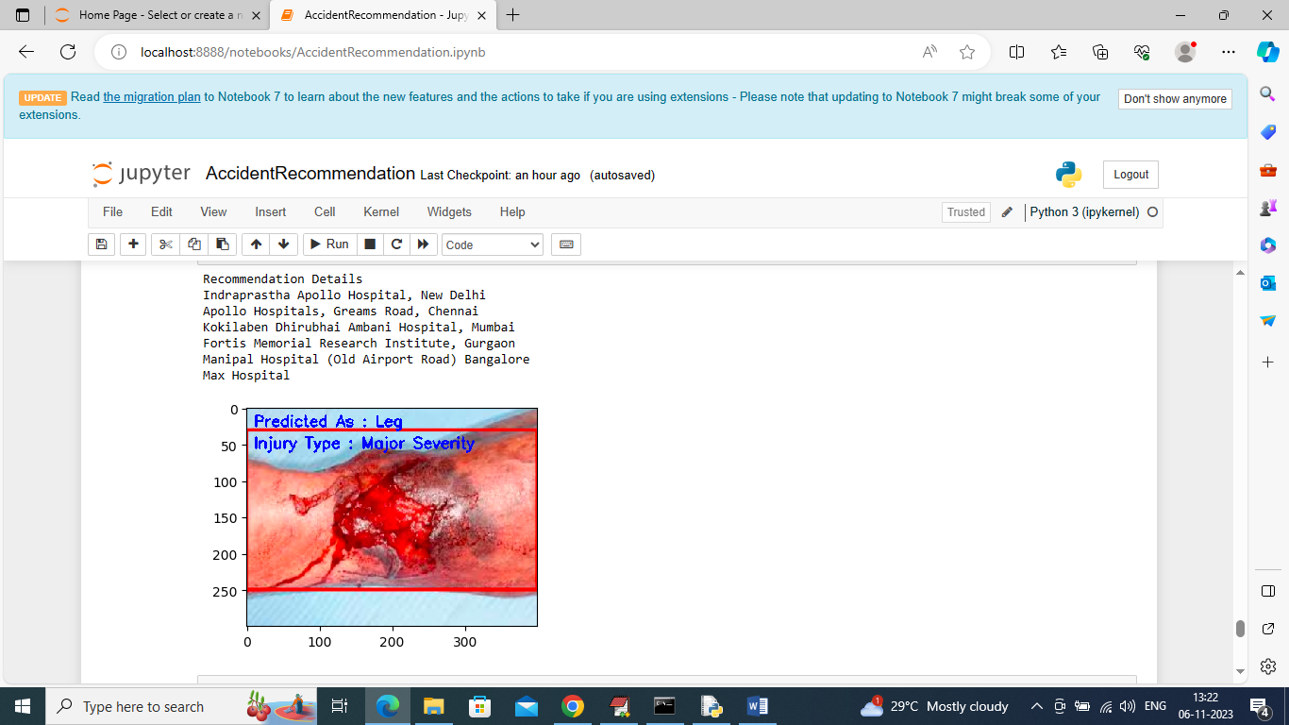

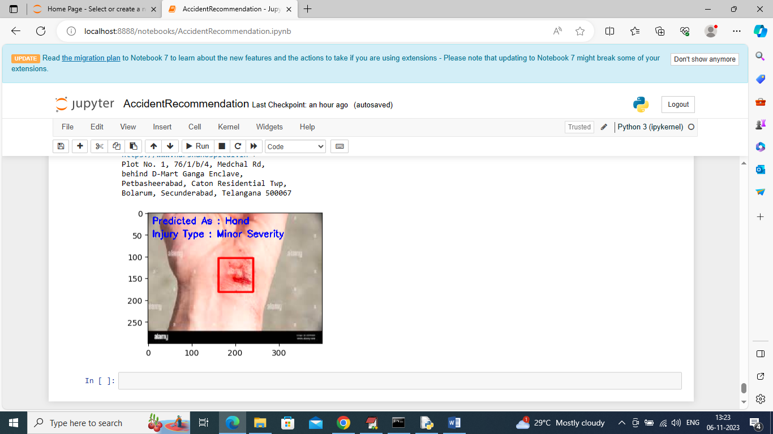

Similarly you can give test image and call predict function to get above output